**Lesson 5 Lesson-End Project**

**Building a Maven Project with Jenkins**



**Steps to be followed:**

1. Install Maven and create a Maven project
2. Create a Jenkins build job to build a Maven project
3. Build a Maven project in Jenkins

**Step 1: Install Maven and create a Maven project**

* 1. Open the terminal.
  2. If you do not have Maven installed already, run the command, ***sudo apt-get install maven***.
  3. Run the command ***mvn -version*** to verify the installation.

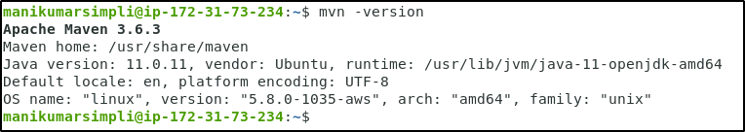

* 1. Go to <https://start.spring.io/> link.
  2. Select **Maven** project and **Java** as a language.

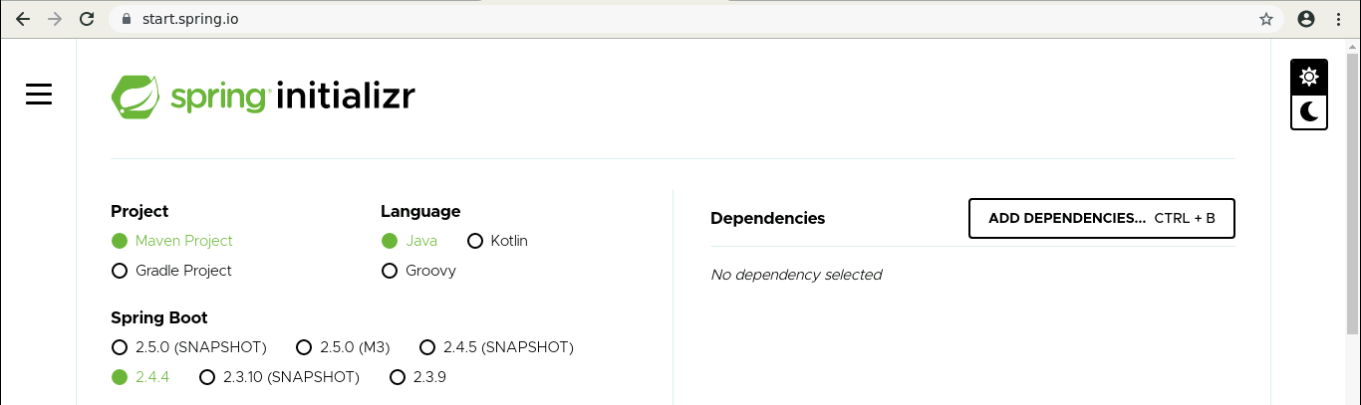

* 1. Provide the required information. Select **Java 11**.

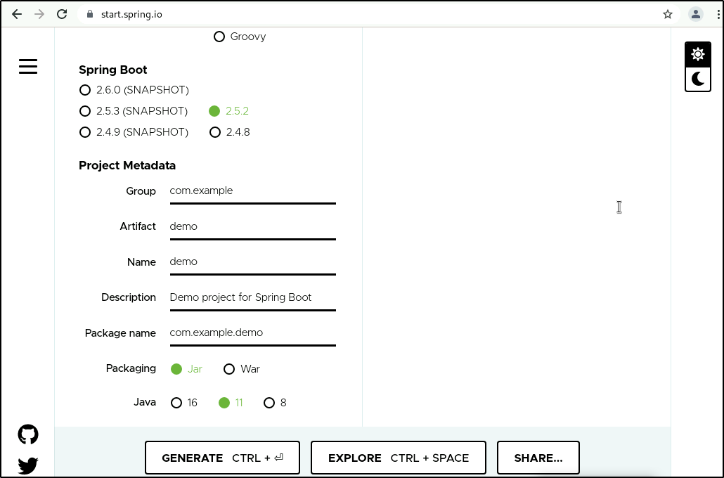

* 1. Click on **GENERATE CTRL+**. The zipped file will get installed in your lab.
  2. Unzip the folder at **/home/<labuser>** location.
  3. Once the command is executed, run ***cd url-checking***
  4. Inside the project directory, run **ls** and find the***pom.xml*** file.

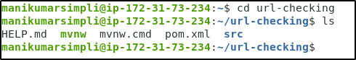

* 1. Open **App.java** in a text editor. Example: ***vi App.java***



* 1. Replace the contents with the below code and save it:

***package com.simplilearn.app;***

***import java.io.IOException;***

***import java.net.HttpURLConnection;***

***import java.net.URL;***

***public class App{***

***public static String checkResponse(String url) throws IOException{***

***HttpURLConnection connection = (HttpURLConnection) new URL(url).openConnection();***

***connection.setRequestMethod("HEAD");***

***int responseCode = connection.getResponseCode();***

***String response = "Success";***

***if (responseCode != 200) {***

***response = "Failed";***

***}***

***return response;***

***}***

***public static void main(String[] args) throws IOException{***

***System.out.println(checkResponse("https:/"+"/samples.openweathermap.org/data/2.5/weather?q=London,uk&appid=b6907d289e10d714a6e88b30761fae22"));***

***}***

***}***

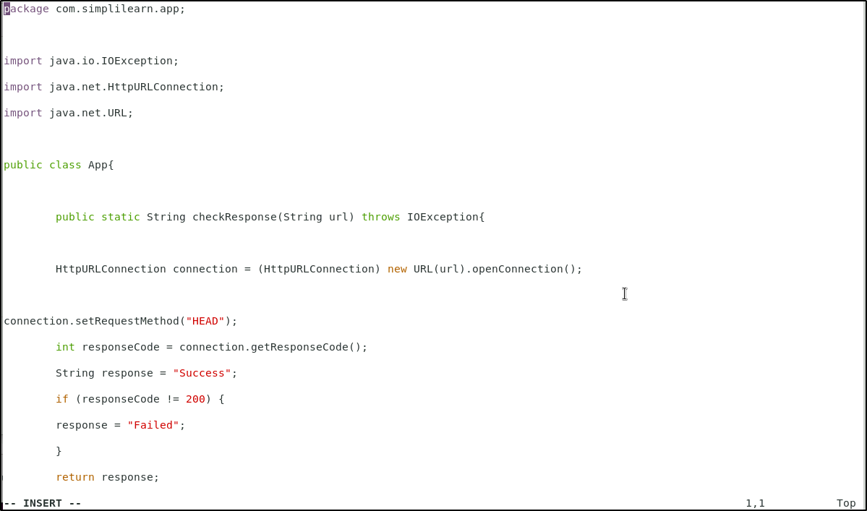

* 1. Click on **esc** and type ***:wq*** to save the file.

**Step 2: Create a Jenkins build job to build a Maven project**

* 1. Open the browser and go to **Jenkins dashboard** by typing **localhost:8080** in your browser.

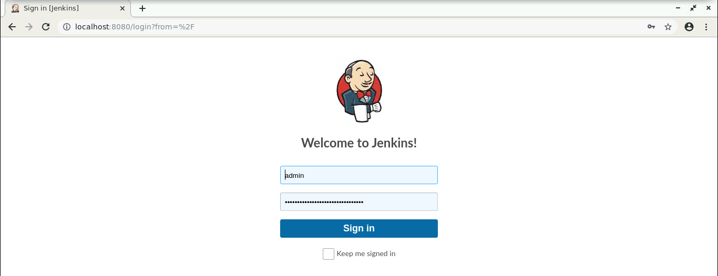

* 1. Provide the credentials and click on **Sign in**.
  2. Click on **New Item** in the Jenkins dashboard.

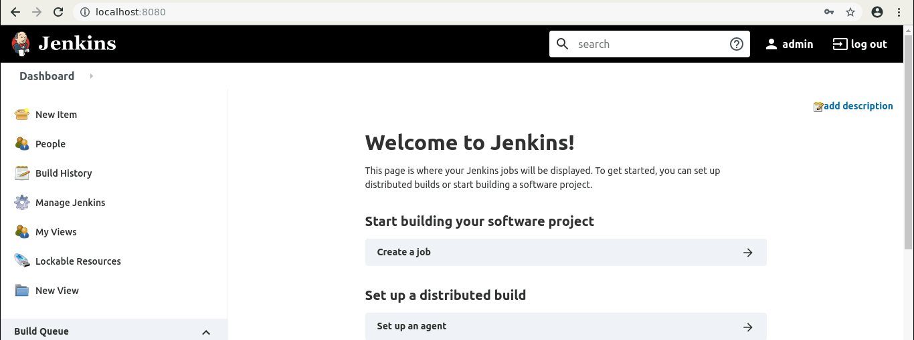

* 1. Enter a name for your project.
  2. Select **Maven project** as the build job type.

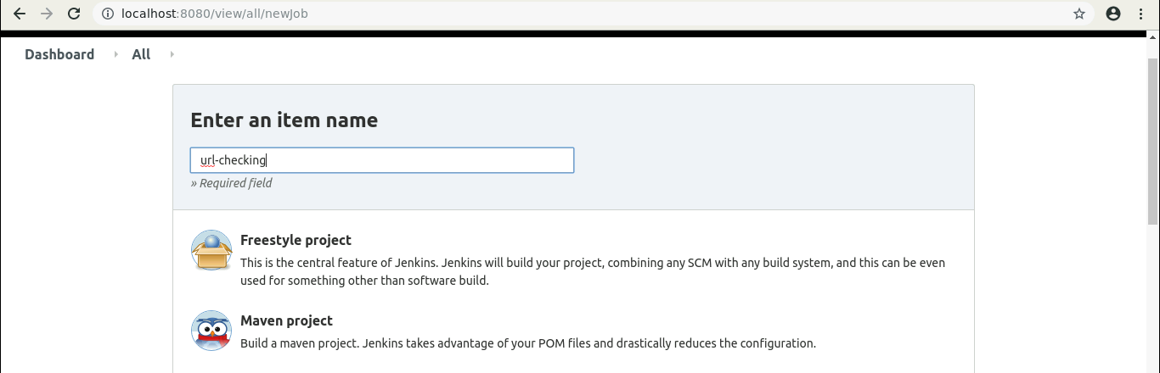

* 1. Click **OK**.
  2. Keep the defaults and scroll down to the **Build** section.
  3. Enter the path to the **pom.xml**.

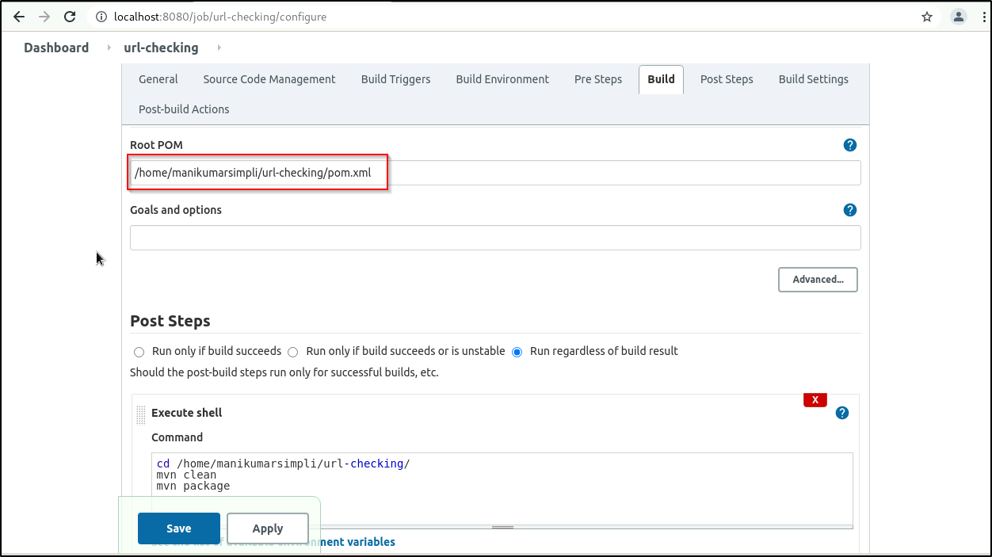

* 1. Scroll down to the **Post Steps** section.
  2. Click on **Add post-build step** and choose **Execute shell** from the drop-down menu.

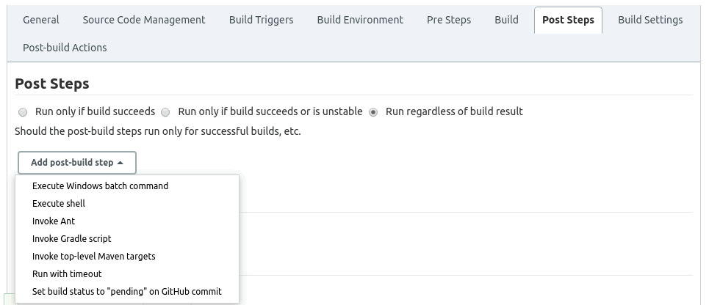

* 1. Enter the following commands in the command section:

***cd /home/<labuser>/url-checking/***

***mvn clean***

***mvn package***

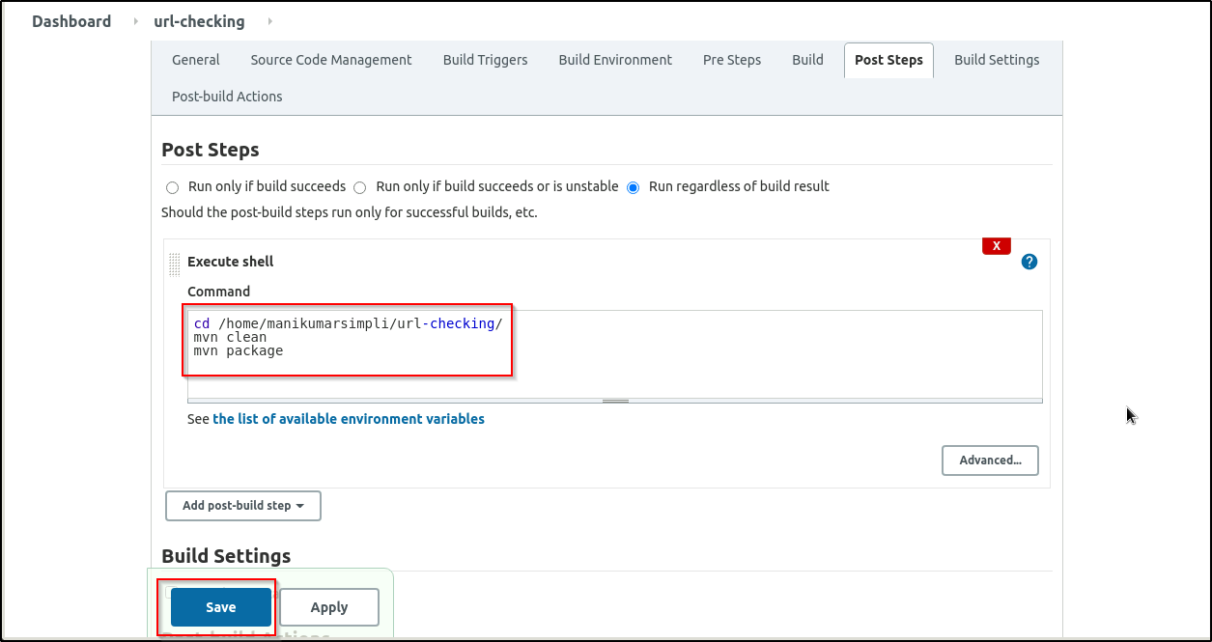

* 1. Click **Save***.*

**Step 3: Building a Maven project in Jenkins**

* 1. Open a new terminal and type ***chmod -R 777 url-checking*** command.
  2. Go to Jenkins **Dashboard**, and click on the project name.
  3. Click **Build Now** in the project window. Jenkins will now build your project.

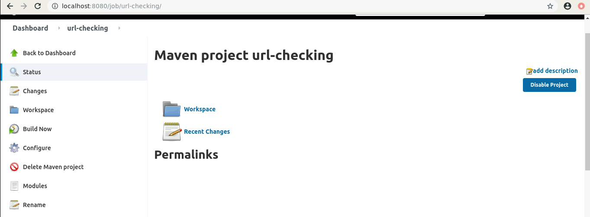

* 1. Click on the **Build History**to view the build results.
  2. Click on the **Console Output** to view the build logs.

